**DETAIL DESIGN**



**Author: IMAGINEERS**

**Date: 13/01/2017**

**Revision history**

|  |  |  |  |
| --- | --- | --- | --- |
| **Version** | **Date** | **Author** | **Notes** |
| **1.0** | 13/01/2017 | Phuong Nguyen | Created |
|  |  |  |  |
|  |  |  |  |
|  |  |  |  |

Contents

I. INTRODUCTION 4

II. PROTOTYPE 4

1. SWAPPAL_REGISTERACCOUNT 4

1.1 Register 4

1.2 Login 4

2 SWAPPAL_MAIN SITE 5

# INTRODUCTION

This document is created to show the design GUI or sketches of the Swappal website. This document is create for

* Scrum Team
* Product Owner

# PROTOTYPE

## SWAPPAL_REGISTERACCOUNT

### Register

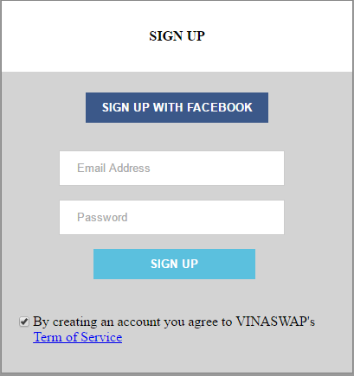

### Login

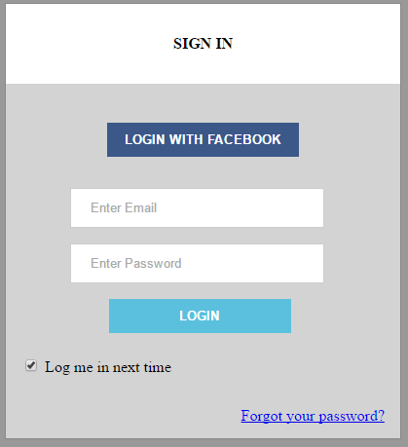

## SWAPPAL_MAIN SITE

